news +++ PCIM
Nuremberg, 9 – 11 June 2026


PCIM Expo & Conference 2026: Discover the Future of Power Electronics

Stuttgart, 13 April 2026. From 9 – 11 June 2026, Nuremberg will once again become the international hub for power electronics. The PCIM Expo & Conference brings together experts from around the world to discuss the latest developments and future trends in the industry. The event provides a comprehensive overview of the innovative products, solutions, and trends that will help shape the power electronics industry in the future. This year, for the first time, a new stage will shine a light on the topic of artificial intelligence and data centers.
Across approximately 40,000 square meters of exhibition space, more than 650 companies from 27 countries will be showcasing their newest and most tried-and-tested technologies. Leading companies such as Mitsubishi, Onsemi, Sumida, and Toshiba will all be in attendance. These will be joined by an array of newcomers, including Allegro MicroSystems, NHK Spring, and Moteon, all of whom will also present their latest innovations. A complete list of this year’s exhibiting companies, as well as the products and solutions they will be presenting, is available in the online exhibitor search on the PCIM website.
Wide range of presentations across four stages
This year, a new presentation stage, the AI & Data Centers Stage, will be joining the Exhibitor, Technology, and E-Mobility & Energy Storage stages at the PCIM Expo 2026 to shine a light on two of the most important future trends in power electronics. The expert presentations and panel discussions will give visitors in-depth insights into current developments, innovative technologies, and practical applications.
Each stage has a different focus to offer a broad selection of illuminating presentations.
Highlights of the Technology Stage
- Fraunhofer IISB: 1200V SiC High-Temperature Power Module as Reference Development Platform
- Fraunhofer IAF: Scaling up the Power of GaN Technologies: Paving the Way for the 1200 V Class and Beyond
- Bosch: Maximizing SiC Power – Is Double-Sided Cooling the Right Choice?
- Infineon: Optimizing Soft-Switching Operation of GaN at High Frequency
Highlights of the AI & Data Centers Stage:
- Yole: GaN Powering the AI Data Center: Enabling Efficient Next-Generation Power Delivery
- ECPE: White Paper on AI in Power Electronics
The E-Mobility & Energy Storage Stage will focus on current and future developments in power electronics for use in electromobility and energy storage. This year, leading companies such as Wolfspeed, Hitachi, and Littelfuse will introduce their applications.
University Research Zone to showcase innovations from academia
At the PCIM Expo 2026, the University Research Zone will offer exclusive access to the most recent findings from power electronics research. Each day will feature different universities and research institutes offering insights into the latest developments from the world of research.
Below are just some of the universities that will be presenting recent projects:
- Stuttgart University: Advanced Wide-Bandgap Semiconductor Reliability Characterization and System Design
- University of Edinburgh: Advancing Wide-Bandgap Power Semiconductors to MW-Class Converter Applications
- University of Southern Denmark: New Generation Electrolytic and Film Capacitors
Conference highlights: a spotlight on artificial intelligence and future-oriented innovations
As usual, the PCIM Expo will be accompanied by the PCIM Conference – an exclusive platform that promotes exchange between the realms of industry and science. Participants can look forward to an extensive line-up of first-rate talks and poster presentations – including numerous first publications from industry and science – that will surpass 500 for the first time.
In addition, the PCIM seminars, which are held over the two days before the exhibition, offer a unique setting for direct discussion of specialized topics along the entire power electronics value chain.
For more information, please visit the homepage of the PCIM – Hub for Power Electronics.

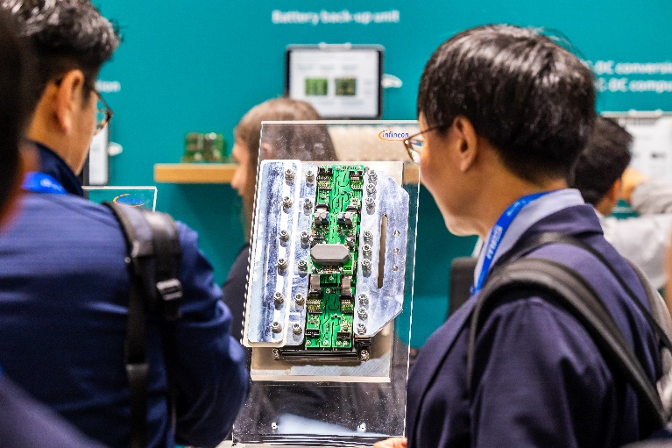
Copyright: Mesago Messe Frankfurt GmbH / Arturo Rivas Gonzalez
PCIM
International exhibition and conference for Power Electronics, Intelligent Motion, Renewable Energy and Energy Management
The PCIM will be held from 09 - 11 June 2026.
Press information and photographic material:
Press - PCIM
Links to websites:
PCIM – Hub for Power Electronics
https://www.facebook.com/pcim/
https://www.linkedin.com/showcase/pcim/

Your contact:
Lisette Hausser
Phone: +49 711 61946-85
Lisette.Hausser@mesago.com
Mesago Messe Frankfurt GmbH
Rotebuehlstraße 83 -85
70178 Stuttgart
Germany
www.mesago.com

Background information on Mesago Messe Frankfurt GmbH
Since 1982, Mesago Messe Frankfurt GmbH has specialized in creating B2B formats for specific technology topics. Having originally emerged from the trade fair and congress sector, the company now offers much more than internationally established technology events. Thanks to the consistent development of its portfolio, Mesago connects leading players worldwide through innovative platforms in the form of industry-specific technology hubs, available 24/7, 365 days a year. Alongside traditional expos and conferences, these hubs comprise digital events, in-depth knowledge formats, and comprehensive services that are tailored to the specific requirements of individual industries.
These hubs create a dynamic space for a timely exchange of information and technological innovation, providing a year-round flow of content. With a view to the ever-changing needs of trade communities, Mesago creates ideal conditions through its forward-looking formats, primarily to further develop an even more efficient global network and to ensure that it is always up to date with the latest developments. This is true to the company's motto: 'Connecting bright minds'.
As part of the Messe Frankfurt Group, Mesago employs around 170 people at its headquarters in Stuttgart, Germany. (mesago.com)
Background information on Messe Frankfurt
www.messefrankfurt.com/background-information
Sustainability at Messe Frankfurt
www.messefrankfurt.com/sustainability-information

