news +++ PCIM
Nuremberg, 9–11 June 2026
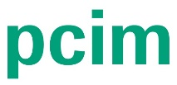

Over 500 presentations from industry and science expected at PCIM Conference 2026
Stuttgart, 19 February 2026. From 9–11 June 2026, the PCIM Conference will once again bring together the leading minds in power electronics and offer real-life experiences of future trends and innovations. This event has always been of vital importance to the surrounding industry, and it is set to demonstrate why by breaking a record in 2026: Participants can look forward to an extensive line-up of first-rate talks and poster presentations – including numerous first publications from industry and science – that will surpass 500 for the first time. Those in attendance will thus benefit from first-hand expert knowledge all along the value chain in power electronics.
Conference participants and trade fair visitors will also receive free access to the PCIM poster sessions, which will take place in Hall 4A. Offering another ideal setting for engaging with experts in person, these sessions present the latest research results, including on IGBT devices, device robustness, novel materials and thermal management, and the modeling and simulation of power electronics systems.
This year, the conference will take place for the first time in NCC Ost at Nuremberg’s exhibition center.

Keynote speeches – artificial intelligence in focus
The keynote speeches held at the start of each day are always a special highlight of the PCIM Conference. Participants will have the chance to attend inspiring, first-class presentations that will focus on current innovative and pioneering topics in the industry.
9 June 2026:
"The GaN Evolution: Lateral, Vertical, and Bidirectional – What's Next?"
Michael Basler (Fraunhofer IAF)
10 June 2026:
"AI Meets Power Electronics: Are We There Yet?"
Uwe Drofenik (Vienna University of Technology)
11 June 2026:
“Transformerless Partial Power Converters: Disruptive Solutions to Reduce Losses, Costs, and Volume"
Thierry Meynard (Laplace – CNRS)

Dive into key subjects at special sessions
In addition to a special session entitled "Artificial Intelligence in Power Electronics" on the second day of the conference, two further sessions are scheduled for 11 June. From 9:50 to 11:10 a.m., the topic will be "GaNius”. When used as a semiconductor material, gallium nitride (GaN) opens up all-new possibilities when it comes to building and integrating circuits for high-frequency power electronics components and efficient, highly compact systems. "GaNius" is also the name of a priority program of the German Research Foundation (DFG).
During the same time slot, a special session on "Power Continuity vs. Power Quality – AI Data Centers” will be moderated by Lorenzo Giuntini (ABB).

First publications from industry and science
The PCIM Conference typically features numerous first publications from industry and science, making it a central platform for sharing knowledge and presenting the latest exciting developments. Conference participants can look forward to myriad program highlights and trending topics, such as:

- Consolidation in SiC power semiconductors
- Bidirectional GaN switches
- SiC superjunction devices – a new breakthrough for the next generation of power transistors
- From standard p-GaN to bidirectional GaN and common-source p-GaN BDS
- New capacitors for operation at high temperatures
- New integrated sensors for circuit protection
- A new development involving JFETs for DC circuit breakers
The industry focus will be on “bidirectional GaN switches” and “consolidation in SiC semiconductors”, among other subjects.
The entire lecture program of the PCIM Conference 2026 is available at https://pcim.mesago.com/nuernberg/en/conference/program-speakers/program.html.

To set a perfect stage for the 2026 event, 27 half-day seminars will offer practical insights and in-depth expertise on the two days prior to the conference. All the relevant information regarding this year’s PCIM seminars can be found at https://pcim.mesago.com/nuernberg/en/conference/seminars.html.

New at the PCIM Expo & Conference: Host Your Side Event!
At this year's PCIM Expo & Conference, companies, speakers, advisory boards, and other participants will have the opportunity to organize an official side event for the first time. Whether it’s networking over drinks, engaging in a roundtable discussion, or going for a morning run: A side event directly connected to the leading trade fair for power electronics can be an exclusive space for exchange, inspiration, and making important new contacts.
To learn more about applying to host a side event, please click here.

The PCIM Expo & Conference is the power electronics industry’s central platform for ground-breaking product premieres, innovations, and the latest research findings. With its unique combination of scientific convention and practically oriented trade fair, the event welcomed 685 exhibiting companies, 16,500 visitors, and more than 800 conference participants from the realms of science and industry in 2025. The PCIM Expo & Conference also drew a record 62% of its attendees from outside Germany last year, underscoring the global relevance of power electronics and reaffirming the PCIM’s position as the leading international event for the power electronics community.
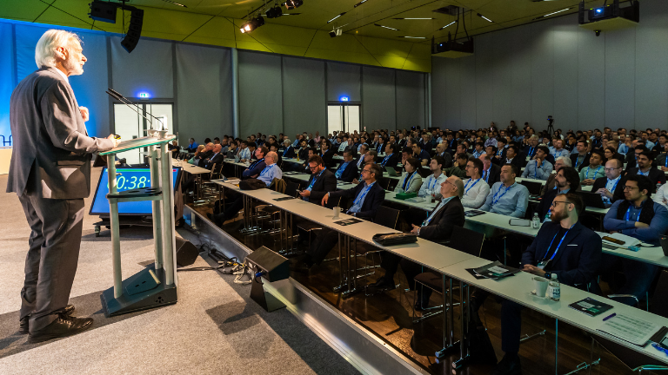
Copyright: Mesago Messe Frankfurt GmbH / Arturo Rivas Gonzalez
PCIM
International exhibition and conference for Power Electronics, Intelligent Motion, Renewable Energy and Energy Management
The PCIM will be held from 09 - 11 June 2026.

Press information and photographic material:
Press - PCIM

Links to websites:
PCIM – the international event in power electronics
https://www.facebook.com/pcimeurope/
https://www.linkedin.com/showcase/pcim-europe/

Your contact:
Lisette Hausser
Phone: +49 711 61946-85
Lisette.Hausser@mesago.com
Mesago Messe Frankfurt GmbH
Rotebuehlstraße 83 -85
70178 Stuttgart
Germany
www.mesago.com

Background information on Mesago Messe Frankfurt GmbH
Since 1982, Mesago Messe Frankfurt GmbH has specialized in creating B2B formats for specific technology topics. Having originally emerged from the trade fair and congress sector, the company now offers much more than internationally established technology events. Thanks to the consistent development of its portfolio, Mesago connects leading players worldwide through innovative platforms in the form of industry-specific technology hubs, available 24/7, 365 days a year. Alongside traditional expos and conferences, these hubs comprise digital events, in-depth knowledge formats, and comprehensive services that are tailored to the specific requirements of individual industries.
These hubs create a dynamic space for a timely exchange of information and technological innovation, providing a year-round flow of content. With a view to the ever-changing needs of trade communities, Mesago creates ideal conditions through its forward-looking formats, primarily to further develop an even more efficient global network and to ensure that it is always up to date with the latest developments. This is true to the company's motto: 'Driving technologies by connecting bright minds'.
As part of the Messe Frankfurt Group, Mesago employs around 170 people at its headquarters in Stuttgart, Germany. (mesago.com)

Background information on Messe Frankfurt
www.messefrankfurt.com/background-information

Sustainability at Messe Frankfurt
www.messefrankfurt.com/sustainability-information

