News +++ PCIM
Nuremberg, 9–11 June 2026


The PCIM Conference Awards 2026: Recognizing Innovative Research
Stuttgart, 9 June 2026. True to the motto that ideas drive progress, the PCIM Conference Awards once again honored the best and the brightest during the opening ceremony of the PCIM Conference 2026. A total of five outstanding papers from industry and academia were recognized across three categories: the Best Paper Award, the Young Engineer Award, and the Young Researcher Award.
With over 600 submissions, this year’s conference underscored its high international relevance and the dynamic progress taking place within the industry. The award-winning papers successfully demonstrate how electronic systems can be developed for even greater performance and sustainability. They also provide vital inspiration for the future, boosting the global competitiveness of the entire industry. This year’s awards were supported by Littelfuse, Mitsubishi, and Semikron Danfoss.

New approaches for the technologies of tomorrow
This year’s awards address important challenges in power electronics; in power semiconductors, innovative gate drive concepts, and advanced energy systems in particular. The quality of the submissions highlights the dynamic progress being made in this industry.
As per tradition, the award-winning papers were selected by the international advisory board of the PCIM Conference, chaired by Prof. Leo Lorenz (ECPE) and Prof. Drazen Dujic (EPFL).
According to Lorenz, “The PCIM Conference Awards bring together the brightest minds in power electronics. This global attention not only brings recognition for the winners, but also gives them access to a unique network to accelerate innovation and promote collaboration.”

Celebrating outstanding work
In the Best Paper Award category, three papers stood out for their depth of research and practical relevance. One winner each was selected for the Young Engineer Award and the Young Researcher Award.

Best Paper Award: Progress through quality research
The Best Paper Award focused on core issues in power electronics, translating innovative approaches into specific solutions. The award-winning papers were as follows:

- Diego Velazco, SuperGrid Institute, France
Lifetime of IGBTs Under Mixed Sequential Power Cycling: A Matched-Lifetime Sequencing Experiment
- Matt Appleby, University of Bristol, UK
Low-Complexity Sub-nanosecond Active Gate Driver for SiC Modules with IV-Trajectory Optimisation
- Kenan Askan, Eaton Industries, Austria
Smart Circuit Breaker for Smart Low Voltage DC Power Grids

Young Engineer Award: practical solution with great promise for the future
This year, the Young Engineer Award went to Axel Wagret (Airbus, France). His paper, titled “Shared DC-Link Optimization for Paralleled Inverters Using Phase-Shifted PWM,” impressed the panel with its practical focus and high industrial relevance. It demonstrates how targeted improvements in the efficiency and performance of modern inverter systems can be achieved through intelligent system optimization and innovative control concepts.

Young Researcher Award: Inspiration from the next generation of academia
Mohamed Alaluss (Technical University (TU) Chemnitz, Germany) received the Young Researcher Award. His paper, titled “Novel Test Concept for Active Short-Circuit Characterization,” offers key insights into switching characterization and new perspectives for the further development of reliable power semiconductors.

Award ceremony on the conference stage
The PCIM Conference Awards were presented by Prof. Leo Lorenz and Prof. Drazen Dujic in a formal ceremony before a live audience. Each of the winners received a cash prize of €1,000.

Abstracts of the best papers from the PCIM Conference 2026

Diego Velazco, SuperGrid Institute, FR
Lifetime of IGBTs Under Mixed Sequential Power Cycling: A Matched-Lifetime Sequencing Experiment

This paper introduces a novel mixed sequential power cycling experiment to investigate load-sequence effects on IGBT lifetime. Two conditions with different junction-temperature swings were alternated with equivalent lifetime fractions. Results show a clear deviation from Miner’s linear damage rule, demonstrating strong sequence-interaction effects in device degradation and providing new insight for more accurate lifetime modeling of power modules.

Matt Appleby, University of Bristol, UK
Low-Complexity Sub-nanosecond Active Gate Driver for SiC Modules with IV-Trajectory Optimisation

Reported active drivers have high fine strength resolution, clock-period-level timing control, and multi-step gate profiles. This work presents a simplified active driver with only two selectable resistances and two steps per profile, yet capable of sub-nanosecond timing adjustment through clock frequency tuning. Experimental results on a 400 A SiC module confirm performance comparable to reported active drivers, whilst achieving reduced hardware complexity.

Kenan Askan, Eaton Industries, AT
Smart Circuit Breaker for Smart Low Voltage DC Power Grids

This paper introduces the first industrialized 100 A / 800 V Smart Semiconductor Hybrid Circuit Breaker (SCHCB) for resilient DC power grids in industrial and data center settings. Compliant with draft IEC 60947-10 and aligned with Current/OS and ODCA, it features advanced fault protection, high-speed switching, and smart grid capabilities including remote control and communication interfaces.

Abstract of the Young Engineer Award paper from the PCIM Conference 2026

Axel Wagret (Airbus, Frankreich)
Shared DC-Link Optimization for Paralleled Inverters Using Phase-Shifted PWM

This study optimizes shared DC-links in dual-inverter systems feeding poly-stator machines by exploiting carrier and modulation phase shifts. The goal is to reduce RMS current, enabling a compact DC-link while meeting lifetime and maximum emissions requirements. A fast MATLAB-based current reconstruction method generates a global RMS mapping for joint converter–machine design. Simulink simulations validate the DC-link gain across different machine configurations without degrading THD.

Abstract of the Young Researcher Award paper from the PCIM Conference 2026

Mohamed Alaluss (Techncal University (TU) Chemnitz, Germany)
Novel Test Concept for Active Short-Circuit Characterization

A novel test concept is presented to reproduce the active short-circuit condition of traction inverters under laboratory conditions. Two high-current IGBTs operating in the active region emulate the bidirectional active short-circuit current. The setup allows flexible adjustment of different active short-circuit waveforms and accurate reproduction. Initial measurements on a 650 V GaN cascode device demonstrate suitability for power device qualification under fault-like conditions.

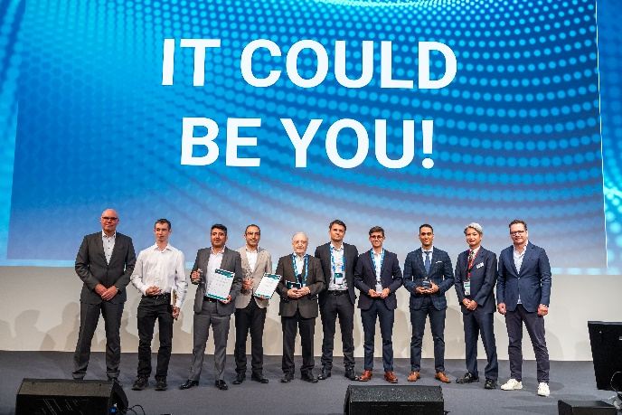
Mesago Messe Frankfurt GmbH / Arturo Rivas Gonzalez
For more information about the event and detailed background information about the PCIM Conference Awards, visit pcim.en.

PCIM
International Exhibition and Conference for Power Electronics, Intelligent Motion, Renewable Energy, and Energy Management
Next year’s PCIM runs from 11–13 May 2027.

Press information and photo material:
Press – PCIM

Links to websites:
PCIM – the event for power electronics
https://www.facebook.com/pcim/
https://www.linkedin.com/showcase/pcim/

Your contact:
Lisette Hausser
Phone: +49 711 61946-85
Lisette.Hausser@mesago.com
Mesago Messe Frankfurt GmbH
Rotebuehlstraße 83 -85
70178 Stuttgart
Germany
www.mesago.com

Background information on Mesago Messe Frankfurt GmbH
Since 1982, Mesago Messe Frankfurt GmbH has specialized in creating B2B formats for specific technology topics. Having originally emerged from the trade fair and congress sector, the company now offers much more than internationally established technology events. Thanks to the consistent development of its portfolio, Mesago connects leading players worldwide through innovative platforms in the form of industry-specific technology hubs, available 24/7, 365 days a year. Alongside traditional expos and conferences, these hubs comprise digital events, in-depth knowledge formats, and comprehensive services that are tailored to the specific requirements of individual industries.
These hubs create a dynamic space for a timely exchange of information and technological innovation, providing a year-round flow of content. With a view to the ever-changing needs of trade communities, Mesago creates ideal conditions through its forward-looking formats, primarily to further develop an even more efficient global network and to ensure that it is always up to date with the latest developments. This is true to the company's motto: 'Connecting bright minds'.
As part of the Messe Frankfurt Group, Mesago employs around 170 people at its headquarters in Stuttgart, Germany. (mesago.com)

Background information on Messe Frankfurt
www.messefrankfurt.com/background-information

Sustainability at Messe Frankfurt
www.messefrankfurt.com/sustainability-information

