news +++ Formnext
Frankfurt, 17–20 November 2026

Formnext 2026 gets off to a flying start with fresh impetus and the UK as partner country
Frankfurt am Main, 3 February 2026. The United Kingdom has been announced as the partner country for Formnext 2026 – with its strong manufacturing background and leading position in Additive Manufacturing, the UK boasts a powerful ecosystem of AM systems, software, and industrial applications. In addition, Formnext is starting the year with fresh impetus and ramping up its focus on key user industries such as orthopedics, aviation, and the automotive sector. Exhibitors looking to take advantage of this momentum have until 2 March to secure an attractive early bird discount for Formnext 2026.

“The UK has long been a key global player in the world of Additive Manufacturing thanks to the close ties with the country’s robust manufacturing industry, and with established system manufacturers such as Renishaw as well as fast-growing companies such as Wayland Additive and many innovative start-ups,” says Sascha F. Wenzler, Vice President Formnext at Mesago Messe Frankfurt GmbH. According to Head of Additive Manufacturing UK (AMUK), Joshua Dugdale, “The UK plays a leading role in the global Additive Manufacturing ecosystem, with strengths spanning research, materials, machine development, software, and high-value industrial applications across aerospace, defence, energy, and healthcare.” Additive Manufacturing UK (AMUK) aims to bring together industry, academia, and government to support innovation, accelerate adoption, and increase the industrial use of AM technologies, positioning UK Additive Manufacturing capabilities on the world stage.

A greater focus on key user industries

In addition, Formnext will this year be placing a greater focus on key user industries, such as orthopedics, aviation, and automotive, through targeted events at leading industry exhibitions. Christoph Stüker, Vice President Formnext at Mesago, explains: “In partnership with our exhibitors and stakeholders, our aim is to shine a light on the specific benefits and potential of Additive Manufacturing in these key industries to appeal to a broader user base.”
To deliver on this commitment, Formnext will thus be hosting a number of special AM-focused events at selected trade shows throughout the year, including the AERO Friedrichshafen (22–25 April 2026), OT-World in Leipzig (19–22 May 2026) and Automechanika in Frankfurt (8–12 September 2026).
“These events will enable us to reach an even broader target audience, some of whom will be unfamiliar with AM, and open their eyes to the possibilities of industrial 3D Printing. Users thus have an opportunity to speak to exhibitors at the various events throughout the year, experience the entire spectrum of Additive Manufacturing at Formnext in Frankfurt in November, and develop specific solutions with our exhibitors,” says Stüker.

More news and early bird discount until 2 March

On its 10th anniversary, Formnext 2025 welcomed a record 38,282 visitors, sending out a strong signal for a successful Formnext 2026.

From Formnext 2026, there will be a new and improved hall structure, with the exhibition taking place across three levels in the future: in Hall 11.0, 12.0 and 12.1. “The new hall structure optimizes the space available to improve visitor flows, reduce walking distances, and create a more vibrant experience overall,” explains Sascha F. Wenzler, adding, “Formnext continues to improve in both its thematic scope and its quality, and the new floorplan accommodates this perfectly.”

Exhibitors who wish to leverage these developments and the growing potential of the AM market can secure an early bird discount by booking until 2 March 2026.

For more information and to register, visit: www.formnext.com/exhibitors

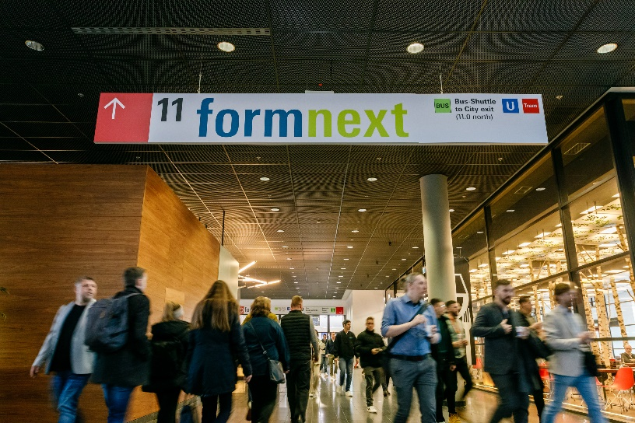
Impressions from Formnext 2025. Copyright Formnext Mesago Messe Frankfurt_Marc Jacquemin
Formnext
International exhibition and convention on the next generation of manufacturing technologies
The Formnext will be held from 17 - 20 November 2026.

Press information and photographic material:
Press - Formnext

Links to websites:
Formnext – Hub for Additive Manufacturing
https://www.facebook.com/formnext
https://www.linkedin.com/showcase/formnext
https://www.instagram.com/formnext/

Your contact:
Franziska Richter Levin
Phone: +49 711 61946-574
Franziska.Richter-Levin@mesago.com
Mesago Messe Frankfurt GmbH
Rotebuehlstraße 83 -85
70178 Stuttgart
Germany
www.mesago.com

Background information on Mesago Messe Frankfurt GmbH
Since 1982, Mesago Messe Frankfurt GmbH has specialized in creating B2B formats for specific technology topics. Having originally emerged from the trade fair and congress sector, the company now offers much more than internationally established technology events. Thanks to the consistent development of its portfolio, Mesago connects leading players worldwide through innovative platforms in the form of industry-specific technology hubs, available 24/7, 365 days a year. Alongside traditional expos and conferences, these hubs comprise digital events, in-depth knowledge formats, and comprehensive services that are tailored to the specific requirements of individual industries.
These hubs create a dynamic space for a timely exchange of information and technological innovation, providing a year-round flow of content. With a view to the ever-changing needs of trade communities, Mesago creates ideal conditions through its forward-looking formats, primarily to further develop an even more efficient global network and to ensure that it is always up to date with the latest developments. This is true to the company's motto: 'Driving technologies by connecting bright minds'.
As part of the Messe Frankfurt Group, Mesago employs around 170 people at its headquarters in Stuttgart, Germany. (mesago.com)

Background information on Messe Frankfurt
www.messefrankfurt.com/background-information

Sustainability at Messe Frankfurt
www.messefrankfurt.com/sustainability-information
Background information on the Working Group Additive Manufacturing (Honorary Sponsor)
Within the Working Group Additive Manufacturing, about 200 companies and research institutes collaborate under the direction of the German industry federation VDMA. Here, plant engineers; component and material suppliers; industrial companies that work with metals and plastics; service providers in software, manufacturing, and processing; and numerous researchers all work toward the same goal: the industrialization of additive manufacturing techniques. (am.vdma.org)

