news +++ Formnext
Frankfurt, 17 – 20 November 2026

Call for Speakers for Formnext 2026 Stage Program Now Open
Frankfurt am Main, Germany, 16 April 2026. In 2026, Formnext will again feature a program of high-quality presentations on key technological, economic, and application-oriented topics in Additive Manufacturing. The call for speakers is now open. Experts from industry, research, and advanced manufacturing are invited to share their developments, findings, or best practices with Formnext’s international audience.
The presentation program has long been an integral element of Formnext, offering visitors the opportunity to expand their expertise in specific areas, gain new impulses for their applications, and make valuable contacts within the AM community. “Our stage program offers the perfect platform for sharing knowledge and experience and is instrumental in promoting the industrial use of additive technologies within specific user industries, but to also between different fields of application,” explains Christoph Stüker, Vice President Formnext, Mesago Messe Frankfurt GmbH.

2026 focus topics and stage format

The program is organized by topic and focuses on current developments in Additive Manufacturing and issues facing the industry. A particular emphasis is placed on sound business cases that demonstrate the economic benefits of additive technologies and provide practical examples of how the integration of AM can make a significant contribution toward industrial value creation. The stage program covers the following topics:

Technology & industrialization (including):
- Automation and scalable production processes
- Design for AM
- Emerging technologies (e.g. bioprinting, food printing, pharmaceuticals)
- The use of Artificial Intelligence in design, process control, and safety
- Models for success and business strategies in the AM industry
- AM industrialization
- Investment, finance, growth, and market trends
- Supply chain management, including cybersecurity
- Sustainable manufacturing solutions and new materials
- Skills and talent

Applications & industries (including):
- Architecture and construction
- Automotive, transportation, and mobility
- Aviation and aerospace
- Energy, oil, and gas
- Mechanical and plant engineering
- Medical and dental technology
- Offshore and marine
- Security and defense
- Tool and die making

The Formnext 2026 program is split over two stages: the Industry & Application Stage and the Technology Stage. The Industry & Application Stage highlights key issues in Additive Manufacturing from an industrial, strategic, and application-oriented perspective. Industry representatives, technology experts, and users discuss the latest developments, present real-world business cases, and offer insights into trends, challenges, and best practices in industrial AM applications. It therefore represents an important venue for knowledge transfer and peer-to-peer exchange. Alongside this, the Technology Stage offers exhibiting companies a platform to showcase their latest products, solutions, and innovations throughout the AM value chain. It is home to technology-focused presentations and new product launches from the exhibitors, ranging from new machinery and materials to software solutions and process innovations.

Participation and application

The call for speakers is now open and is aimed at anyone who would like to share their expertise and experience with international manufacturing experts and the AM community. Taking part will give you the opportunity to establish yourself as an expert in your field, showcase the latest developments, and expand your network in a highly relevant setting. The deadline for applications is 30 June 2026.

For more information and the application form, visit:
www.formnext.com/callforspeakers

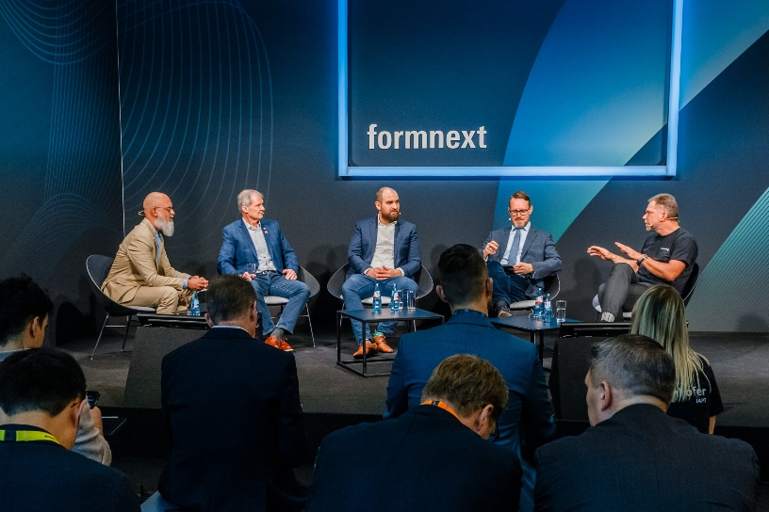
Panel discussion at Formnext 2025. Copyright Formnext Mesago Messe Frankfurt_Marc Jacquemin

Formnext
International exhibition and convention on the next generation of manufacturing technologies
The Formnext will be held from 17 - 20 November 2026.

Press information and photographic material:
Press - Formnext

Links to websites:
Formnext – Hub for Additive Manufacturing
https://www.facebook.com/formnext
https://www.linkedin.com/showcase/formnext
https://www.instagram.com/formnext/

Your contact:
Franziska Richter Levin
Phone: +49 711 61946-574
Franziska.Richter-Levin@mesago.com
Mesago Messe Frankfurt GmbH
Rotebuehlstraße 83 -85
70178 Stuttgart
Germany
www.mesago.com

Background information on Formnext
Formnext is the hub for Additive Manufacturing, industrial 3D Printing and the next generation of intelligent manufacturing solutions. In addition to the annual highlight, the expo in Frankfurt/Germany, we provide our clients worldwide with a variety of relevant updates, insights and events around Additive Manufacturing (AM) as well as the related technologies along the entire process chains. Formnext is organized by Mesago Messe Frankfurt GmbH (formnext.com).

Background information on Mesago Messe Frankfurt GmbH
Since 1982, Mesago Messe Frankfurt GmbH has specialized in creating B2B formats for specific technology topics. Having originally emerged from the trade fair and congress sector, the company now offers much more than internationally established technology events. Thanks to the consistent development of its portfolio, Mesago connects leading players worldwide through innovative platforms in the form of industry-specific technology hubs, available 24/7, 365 days a year. Alongside traditional expos and conferences, these hubs comprise digital events, in-depth knowledge formats, and comprehensive services that are tailored to the specific requirements of individual industries.
These hubs create a dynamic space for a timely exchange of information and technological innovation, providing a year-round flow of content. With a view to the ever-changing needs of trade communities, Mesago creates ideal conditions through its forward-looking formats, primarily to further develop an even more efficient global network and to ensure that it is always up to date with the latest developments. This is true to the company's motto: 'Connecting bright minds'.
As part of the Messe Frankfurt Group, Mesago employs around 170 people at its headquarters in Stuttgart, Germany. (mesago.com)

Background information on Messe Frankfurt
www.messefrankfurt.com/background-information

Sustainability at Messe Frankfurt
www.messefrankfurt.com/sustainability-information
Background information on the Working Group Additive Manufacturing (Honorary Sponsor)
Within the Working Group Additive Manufacturing, about 200 companies and research institutes collaborate under the direction of the German industry federation VDMA. Here, plant engineers; component and material suppliers; industrial companies that work with metals and plastics; service providers in software, manufacturing, and processing; and numerous researchers all work toward the same goal: the industrialization of additive manufacturing techniques. (am.vdma.org)

