news +++ Formnext
Frankfurt, 18–21 November 2025

Formnext celebrates 10 years with extended event program
Frankfurt am Main, 11 November 2025. To commemorate its 10th birthday, Formnext – the world's largest trade fair for Additive Manufacturing and the next generation of production – is expanding its event program. Along with the successful formats attendees have come to expect, including three stages, numerous special showcases, the Formnext Awards, a featured partner country (Spain), and specialized seminars and events, new highlights such as focused trade fair tours, live AM shows, and interactive features are set to be added this year.
“By expanding our event program, we’re addressing current developments in the world of Additive Manufacturing,” explains Christoph Stüker, Vice President of Formnext at Mesago Messe Frankfurt GmbH. “The range of industrial applications grows every year, and more and more people are gaining access to this innovative technology. At the same time, the AM industry is demanding ever more economical, but also more specialized solutions.”

Three stages, one focus: topics that drive the AM industry

Formnext addresses challenges like these through its diverse stage program, which all trade fair visitors are welcome to attend. Every year, renowned experts come together to discuss current and future applications, technologies, and trends in the AM and wider production industry.

On the Application Stage (Hall 11.1, E69), a variety of innovative additive applications will be discussed, from individual orthoses, jewelry, and watches to rocket engines, robot components, pipelines, and spare parts for wind turbines. The focus here is primarily on economic efficiency. The Industry Stage (Hall 11.0, D72), meanwhile, is dedicated to overarching topics that affect the AM industry, such as sustainability, the industrialization of AM, and “Design for AM”. AI-generated consumer products and the 3D Printing of mushroom mycelium are just two specific examples. Finally, exhibitors’ latest innovations will also be presented on the Technology Stage (12.1, B49).

Important conference topics: decentralized manufacturing, desktop 3D printers, and much more
In a further nod to Formnext’s 10th anniversary, the Industry Stage will feature a keynote speech followed by a panel discussion that will look back on AM developments over the past decade, as well as forward to the years ahead. Meanwhile, another panel on mergers and acquisitions will address the current consolidation movements in the AM world, and regional, national, and international initiatives will also be presented and discussed. Also poised to play a prominent role in this year’s stage program is one of the particular strengths of Additive Manufacturing across all the relevant industries, namely decentralized production. Among other advantages, this trend offers particular potential when it comes to rethinking supply chains. An important component of this process is the increasing significance of relatively inexpensive desktop 3D printers, which are also becoming more common in the industrial environment. The 2025 Formnext stage program will also be dedicated to the opportunities and challenges this “democratization of AM” presents – especially from the perspective of small and medium-sized companies.

AM knowledge for beginners and experts
In addition, the highly popular Discover3DPrinting seminars, which are held in cooperation with the Aachen Center for Additive Manufacturing (ACAM), will take place daily on the Application Stage. Here, newcomers to AM can gain an overview of the field along with plenty of key insights. These will be complemented by DeepDives into the topics of large-format plastic 3D Printing, the rise of DED technology, data-driven design, and the scaling of 3D Printing on the Technology Stage.

New formats: guided tours, livestream, and quiz show
This year’s new offerings will also include guided tours of Formnext with a focus on post-processing. In this way, Formnext is recognizing the importance of this often underestimated, but tremendously important part of AM production. The tours, which will take around an hour and a half and be led by renowned AM and industry experts, will take place on Wednesday, 19 November (in German) and Thursday, 20 November (in English) from 2:00 pm. The meeting point will be in the foyer in front of Hall 12.0. Advance registration is not required. Participation is based on a “first come, first served” basis.
Two more components of the Formnext supporting program will be “Show and Telling LIVE”, a livestream set to be offered by YouTuber and content creator 3D Printing Nerd on Tuesday afternoon in Hall 11.0, and the Ultimate Additive Quiz Show on Wednesday evening on the Technology Stage.

Special showcases to cover everything from mechanical engineering to art
The special showcases at Formnext 2025 will provide even deeper insights into AM applications in specific industries. At Additive4Industry (Hall 12.0, B01), the VDMA's Additive Manufacturing working group will present valuable AM applications from the world of mechanical engineering. The BE-AM Symposium (19 November in the Portalhaus, room “Transparenz”) and corresponding special showcase (11.0, F49) will cover developments in the increasingly important field of 3D Printing in the construction industry. The AM Art Space (Hall 11.0, D82), which is being organized in cooperation with SUTOSUTO, will focus on the combination of Additive Manufacturing and art. The AM Innovation and Standards Summit at Formnext (Hall 4.0, room “Europa”), which will take place the day before the trade fair (17 November) in cooperation with ASTM International, will focus on international norms and standards. The keynotes, meanwhile, will deal primarily with industry-specific approaches, success stories, and challenges in the qualification and certification of AM.

In the Start-up Area (Hall 11.0, D62) and at the Young Innovators joint booth of the Federal Ministry for Economic Affairs and Energy (Hall 12.1, B39), young, innovative companies will have the chance to present themselves and make important contacts, including with potential investors and partners. These firms will also introduce themselves at a Pitchnext event scheduled for 2:15 pm on the Industry Stage (Hall 11.0, D72) on 18 November.

Whether it’s young newcomers to AM or experienced specialists in the field, the Career Area in Hall 11.0 will offer information about current job opportunities in AM to those looking for a new challenge. Along with the openings posted to the Job Wall, attendees will be able to obtain career advice and have professional headshots taken on 20 November.

Formnext Awards
Meanwhile, the Formnext Awards will once again honor innovative young companies, sustainable business ideas, and groundbreaking technologies in six different categories. The finalists' ideas will be presented on the Formnext website, as well as at Formnext itself. Just like last year, attendees are invited to take part in the online voting to decide the winners. These will then be announced during the award ceremony scheduled for 4:20 pm on the Industry Stage on Thursday, 20 November.

Partner country: Spain
This year's partner country will present itself with the help of numerous innovative exhibitors at Formnext 2025. Spain has been one of the leading exhibitor countries at Formnext over the years, and around 30 companies will be on hand to continue that tradition. The Spanish AM industry is particularly strong in the areas of AM systems, materials, and R&D.

Further information:
To find out more about tickets and all the other important aspects of attending Formnext, please visit: www.formnext.com/visitors

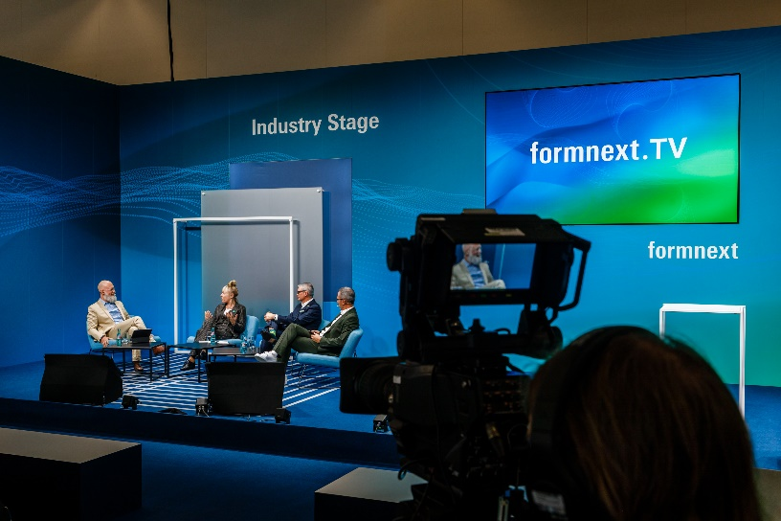
The Industry Stage at Formnext 2024. Copyright Formnext Mesago, Marc Jacquemin

Formnext
International exhibition and convention on the next generation of manufacturing technologies
The Formnext will be held from 18 - 21 November 2025.

Press information and photographic material:
Press - Formnext

Links to websites:
Formnext – Hub for Additive Manufacturing
https://www.facebook.com/formnext
https://www.linkedin.com/showcase/formnext
https://www.instagram.com/formnext/

Your contact:
Franziska Richter Levin
Telefon: +49 711 61946-574
Franziska.Richter-Levin@mesago.com
Mesago Messe Frankfurt GmbH
Rotebuehlstraße 83 -85
70178 Stuttgart
Germany
www.mesago.com

Background information on Formnext
Formnext is the hub for Additive Manufacturing, industrial 3D Printing and the next generation of intelligent manufacturing solutions. In addition to the annual highlight, the expo in Frankfurt/Germany, we provide our clients worldwide with a variety of relevant updates, insights and events around Additive Manufacturing (AM) as well as the related technologies along the entire process chains. Formnext is organized by Mesago Messe Frankfurt GmbH (formnext.com).

Background information on Mesago Messe Frankfurt GmbH
Mesago, founded in 1982 and located in Stuttgart, specializes in exhibitions and conferences on various topics of technology. The company belongs to the Messe Frankfurt Group. Mesago operates internationally and is not tied to a specific venue. With around 160 members of staff Mesago organizes events for the benefit of more than 3,300 exhibitors and over 110,000 trade visitors, conference delegates and speakers from all over the world. Numerous trade associations, publishing houses, scientific institutes and universities work with Mesago closely as advisers, co-organizers and partners. (mesago.com)

Background information on Messe Frankfurt
www.messefrankfurt.com/background-information

Sustainability at Messe Frankfurt
www.messefrankfurt.com/sustainability-information
Background information on the Working Group Additive Manufacturing (Honorary Sponsor)
Within the Working Group Additive Manufacturing, about 200 companies and research institutes collaborate under the direction of the German industry federation VDMA. Here, plant engineers; component and material suppliers; industrial companies that work with metals and plastics; service providers in software, manufacturing, and processing; and numerous researchers all work toward the same goal: the industrialization of additive manufacturing techniques. (am.vdma.org)

