news +++ EMV
Cologne, 24–26 March 2026

New year, new topics at the EMV 2026 – Registration for Congress and Workshops now open!
Stuttgart, 15 January 2026. The new year brings important news for the EMC community. The current EMV Congress and Workshop program is now available. Featuring new highlights, the international Expo and Conference for Electromagnetic Compatibility, held from March 24 to 26, 2026 will once again serve as the central knowledge and presentation platform for research, industry, and practice in Cologne. Those wishing to attend can register now. The early bird discount is valid until February 10, 2026.
This year's EMV event once again offers the successful combination of expo, congress, and workshops. This interplay enables targeted further training, extensive networking opportunities, and direct access to new EMC products. Participants benefit from the high-quality, user-oriented program, in particular. For 2026 specifically, this includes knowledge from eleven thematically focused congress sessions, each with three to four presentations, as well as twenty intensive practical workshops. The international expo showcasing the latest products and trends rounds off the offering. The main focus is on exchanging ideas with experts from a variety of industries.

A new special session expands diversity of congress

New for 2026 is an Experiments and Live Demonstrations Session on the last day of the expoeaturing three presentations. The program also includes a keynote speech on the new European AI Regulation, focusing on its implications for the EMC industry. The agenda was compiled and evaluated by the EMV event Committee, which consists of 39 technical experts. This curated selection guarantees topicality, technical depth, and practical relevance.

"Our varied program is sure to have something for everyone, whether our attendees are beginners or EMC specialists. Now is the time to register for the upcoming EMC congress. For many, participating is a valuable investment in their professional future. We address current industry topics and provide an excellent platform to showcase expertise and build a strong reputation as a speaker," explains Jeannette Meyer, Vice President of the EMV Hub for Electromagnetic Compatibility at Mesago Messe Frankfurt GmbH.

The EMV congress offers individualized knowledge advantages

The EMV congress is particularly aimed at specialists, managers, and young engineers. It provides experts in the field of science with a platform to present their latest developments. Thanks to the diverse range of offerings, interested parties can create a personalized education program and apply what they learn to their everyday practice. There are also arguments from the university side for not missing the EMV 2026:

"The EMV in Cologne is the central location where the EMC community likes to gather. It is a place where the exchange of the latest scientific findings from universities and practical requirements in industry takes place in a simple and effective manner which is otherwise difficult – in technical presentations, discussions at the trade fair, and, of course, at the evening events. We look forward to Steffen Bach's presentation on network analyzer methods for validating mode turbulence chambers. Steffen is a former student whose contribution is based on discussions from the last EMV. It's worthwhile for our entire working group to regularly participate in the EMV to generate ideas for interesting research questions," confirms Dr. Mathias Magdowski, a member of the EMV committee and professor at Otto von Guericke University in Magdeburg.

The current congress program and general information on registration and the EMV 2026 are available on the website. Further details and an overview of all relevant highlights will be published in a separate press release.

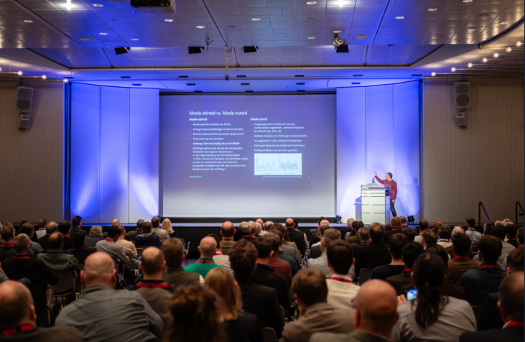
Copyright: Mesago Messe Frankfurt GmbH / Matthias Kutt

EMV
Hub for electromagnetic compatibility
International trade fair with workshops on electromagnetic compatibility (EMC)
The EMV will be held from 24 - 26 March 2026.

Press information and photographic material:
Press - EMV

Links to websites:
EMV – Hub for Electromagnetic Compatibility https://www.linkedin.com/showcase/emv---international-exhibition-on-electromagnetic-compatibility-emc-

Your contact:
Jeannette Meyer
Phone: +49 711 61946-290
Jeannette.Meyer@mesago.com
Mesago Messe Frankfurt GmbH
Rotebuehlstraße 83 -85
70178 Stuttgart
Germany
www.mesago.com

Background information on Mesago Messe Frankfurt GmbH
Since 1982, Mesago Messe Frankfurt GmbH has specialized in creating B2B formats for specific technology topics. Having originally emerged from the trade fair and congress sector, the company now offers much more than internationally established technology events. Thanks to the consistent development of its portfolio, Mesago connects leading players worldwide through innovative platforms in the form of industry-specific technology hubs, available 24/7, 365 days a year. Alongside traditional expos and conferences, these hubs comprise digital events, in-depth knowledge formats, and comprehensive services that are tailored to the specific requirements of individual industries.
These hubs create a dynamic space for a timely exchange of information and technological innovation, providing a year-round flow of content. With a view to the ever-changing needs of trade communities, Mesago creates ideal conditions through its forward-looking formats, primarily to further develop an even more efficient global network and to ensure that it is always up to date with the latest developments. This is true to the company's motto: 'Driving technologies by connecting bright minds'.
As part of the Messe Frankfurt Group, Mesago employs around 160 people at its headquarters in Stuttgart, Germany. (mesago.com)

Background information on Messe Frankfurt
www.messefrankfurt.com/background-information

Sustainability at Messe Frankfurt
www.messefrankfurt.com/sustainability-information

